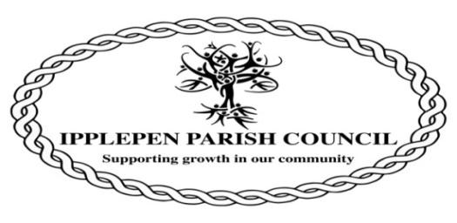
Clerk to the Council : Cat Freston
17, Fairview Road
Denbury
TQ12 6ET
(01803) 813250
Email:ipplepencouncil@btopenworld.com
AMENITIES COMMITTEE MINUTES OF IPPLEPEN PARISH COUNCIL HELD ON TUESDAY 8 NOVEMBER 2022

Attendees.
Cllr R Carnell (RC)-Chair
Cllr D Palethorpe (DP)
Cllr D Burnham (DB)
Cllr Ranjit (JR)
Cllr B Jerwood (BJ)

The meeting opened at 19:30 hours

1. The Chairman will open the Meeting and receive apologies.
No apologies received, all present

2. To declare any interests arising at this meeting and to consider any dispensation requests relating to this meeting.
No interests were declared.

3. The Council will adjourn for the following items:
Public Question Time: A period of 10 minutes will be allowed for members of the public to ask questions or make comment regarding the work of the Council or other items that affect Ipplepen

Three members of IpplePlanet were present at the meeting.

During recent weeks, a number of emails and threads of communication have been raised between Mary Rush, Teignbridge Biodiversity Officer, Mable Harris (MH), IpplePlanet, and David Palethorpe (DP), Chair of Ipplepen Parish Council.

In summary, the discussions were in respect of an initial informal approach by the chief spokesperson for the IpplePlanet organisation, Mabel Harris, to Teignbridge District Council (TDC) regarding the potential forthcoming plans for the skatepark and associated hedge removal /reduction. It was deemed by the members of the Parish Council that by approaching TDC, IpplePlanet had acted way in advance of any discussions regarding the future of the skatepark hedge and, outside the parameters of the working group remit.

In response to the situation, DP had written to MH highlighting the original discussions that had taken place and that no application or decision had been formally proposed by IPC. DP advised that it was regrettable that IpplePlanet appeared to have misinterpreted the original discussions regarding the hedge row.

MH advised her thoughts on the correspondence received from DP and questioned if there was a future for the parties to continue working together. DP responded by highlighting that if IPC were to continue working closely with IpplePlanet on future ecology projects, that closer collaboration was required between the two parties to avoid the potential of any future misunderstanding and dispute. DP and MH agreed that going forward, for IPC and IpplePlanet to work together effectively, a set of group guidelines was required to be drawn up which would ensure that each party was aware of their respective remits and limits of decision making. It was agreed that lines of responsibility and terms of reference are required to drawn and understood/agreed by both parties-DP to action.

IpplePlanet have been assured that IPC are fully committed to improving the environment for the parishioners and are happy to continue working alongside IpplePlanet in considering any future proposals on land/property owned or under the authority of the IPC.

Going forward it was agreed that free tree distribution to public can be organised by IpplePlanet using recreation ground etc. MH to advise date etc.

Action Climate Teignbridge to cover liability insurance when works are being carried out by IP.

IP to advise IPC of potential dates for agreement prior to publicising any events

4. The Council will convene to conduct the following business:

- Arrange marshalling for Remembrance Sunday 13th November and the Carol Service on 21st December 6.45 to 8.00 pm.

RC & BJ to distribute signage and cones where required.
Scouts to manage road closures.
4 x road closure signs to be positioned.
Church service from 10:00am.

Signage to be repositioned again for Carol Service to restrict access

- Allotment water supply.
In hand. Not advisable to excavate area and install water pipe at present due to wet ground conditions and potential long lasting effect on the ground.

- Earthing mat for the park electric supply
Jack Wood advised that he had electric shock. Earth mat required to be installed.
PC agreed to installation if value less than £500

- Skate Park - planning?
-DP advised that we can use same footprint, use other side of hedge, incorporate into where basketball area located.
-Require consultation. Go to full council and obtain approval with design, professional advice, funding etc.

- (SLG)- Signing, lighting & Guarding certificate do we need anyone to requalify?
Certificates in hand. Issuing of certificates hastened with training body

AOB-
Jubilee Bench-from Glason,DP to follow-up

Toilet redecorating- DB awaiting response from Lee Fewing in respect of the request for re-validation of existing quotation due to delays incurred with the commencing of the works

5. To note the date of the next meeting: Tuesday 13th December 2022

There being no further business the meeting closed at: 20;32 hrs

