IPPLEPEN PARISH COUNCIL

Minutes of Meeting held virtually by Webex Meetings

On Tuesday 2nd March 2021

In attendance:

Coun.Carnell (Chairman) Coun.Farrow
Coun.Mrs.Calland Coun.Mrs.Hutchings
Coun.Palethorpe Coun.Rattlidge

Coun.Ranjit Coun.Smith
Coun.Armitage Coun.Mrs.Olding (Vice Chairman)

Miss.C.Freston Parish Clerk
Coun.Dewhirst District/County Councillor

One Member of the public

136) APOLOGIES – No apologies

137) DECLARATIONS OF INTEREST – No declarations of Interest

138) MINUTES OF THE LAST MEETING
Minutes of the meeting held on Tuesday 2nd February 2021, were approved and signed by the Chairman.

139) PUBLIC QUESTION TIME – No comments

140) CORRESPONDENCE – Parish Clerk
a) An allotment holder has emailed seeking permission to build a den on their allotment plot Action – The Clerk to contact and ask for dimensions.
b) An email has been received regarding On Street EV Chargepoints. Coun.Carnell met the company at the Mill Centre on Tuesday 2nd March 2021. They are going to find out about the electricals at the site and will report back to Coun.Carnell.
c) An email has been received from a parishioner about sponsoring a tree or a bench in the Village. Action – Coun.Palethorpe to contact and discuss further.

REPORTS FROM OUTSIDE BODIES - None

141) DISTRICT & COUNTY COUNCILLOR’S REPORT – Coun.Dewhirst

County Matters
Climate conscious Devon residents are being urged to reduce their carbon footprint by cutting down on the clothes they buy. If residents do have to buy new clothes, they are encouraged to buy better-quality, ethically sourced items, preferably from a local retailer.
The ‘fast fashion’ industry is the second highest carbon-creating industry in the world and emissions from textile production outweigh the total carbon footprint of international flights and shipping combined. Producing the clothes we wear creates 1.2 billion tonnes of CO2e each year, accounting for over 10 per cent of all global carbon emissions.
The production of a single t-shirt creates the same amount of emissions as driving from Exeter to Plymouth, and in Devon around 6,500 tonnes of textiles are still ending up in waste bins each year.
If re-used instead of binned, this would save 33,800 tonnes of CO2. £30 billion of unworn clothing is sitting in UK wardrobes, do we really need to be buying even more?
The highest contributor to the carbon footprint of clothing is the production and processing of fibre, whether natural or synthetic. This can be reduced by making the most of the clothes we already have, buying second-hand items online or when charity shops are open, and swapping with friends and family. If residents avoided buying new clothes for a whole year, it would save a staggering 132,860 tonnes of CO2.
For more information about reducing and reusing clothing, please follow Recycle Devon on Facebook, Twitter and Instagram or visit www.recycledevon.org.
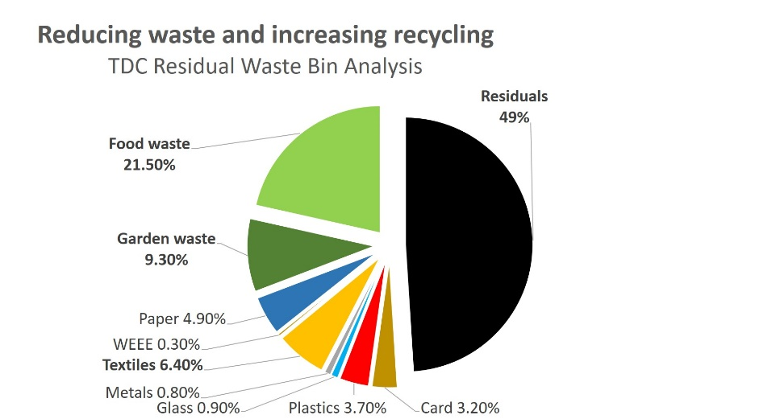

Three weeks ago, saw the start of Devon’s £578.5 million Budget process. Monday saw the Children’s Scrutiny Committee looking at their £158.3 million budget. What is really terrifying is that we were told the High Needs Block negative reserve will reach £78 million by the end of 2022 – at this rate it will consume the Council in a couple more years. Tuesday saw the £282.5 million budget for Adult services being scrutinized – it is nearly half the total budget.
A marathon session the CIRS Scrutiny Committee looked at £39.9 million Communities budget (a 0.2% increase), the £40.4 million Corporate budget (a 7.5% increase) and the Highways £57.5 million budget (a 0.5 % decrease). We were staggered that there were to be cuts to winter operations and Highway Network management.
Following representations made by my Party and the recommendations made by Scrutiny the Leader announced an extra £600,000 would be added to the county council’s roads budget under a new plan announced at Cabinet.
At Council, surprisingly, there was no amendment to the Budget from Labour who abstained from voting on the Budget or its proposed Amendments but spoke in favour of the Conservative Budget!
The Lib Dem Budget amendment which comprised investing £3.4 million on fixing Devon’s roads (filling potholes, routine maintenance, repainting white lines and investing in cycling and walking); £1/2 million on supporting communities who want 20 mph zones; £1/2 million on Green Devon schemes (Bee corridors, wildflower verges; £1 million supporting “Made in Devon” and “Bought in Devon” schemes and £3/4 million for mental health support for children. This all to be paid for by a draw down from the £64.4 million Budget Management Reserve set up to support this very type of thing.
Finally, this amendment sought to end the tax loophole whereby second homeowners can switch from Council Tax to Business rates and then claiming small business exemptions.
You won’t be surprised to know that many Conservative Councillors echoed the North Devon MP’s call for Highway improvements but failed to vote for the amendment that would have actually given them those improvements!
After 4 hours of debate the Council voted for a 4.99% increase in Council tax which comes down to £1,511.28 per Council Tax band D property for 2021/22.
District Matters
The Local Restrictions Support Grant scheme for businesses severely impacted by the Tier 2 restrictions is now open for applications. Both rated and non-rated Teignbridge businesses (in any sector) can apply, including businesses that work from home or on a mobile basis. Those who applied for an LRSG for the November 2020 lockdown are welcome to apply for this scheme too.
Grants for the new lockdown period will go live in early February. TDC are also working on a new ‘grant checker’ that will allow businesses to work out which schemes they are eligible for. In the meantime, TDC are asking members and officers to signpost businesses to our grant summary table on the website under Business.
https://www.teignbridge.gov.uk/business/business-support-and-advice/business-help-and-support-during-coronavirus/
https://www.teignbridge.gov.uk/coronavirus-covid-19/
________________________________________

A budget to promote social and economic recovery and balance the books was the proposal going before Teignbridge Council’s meeting on 22nd February.
The plans propose a range of measures that will set the Teignbridge economy on a course of recovery, as well as offsetting the income loss resulting from the impact of the year-long pandemic. An increase in council tax Band D of £5, and the use of grants and other measures will enable Teignbridge to continue with its ambitions to tackle climate change; increase support for housing, including making good its commitment to build affordable housing in the district. It will also focus on delivering some of its key infrastructure to secure employment and enhanced community settings.
Recommendations that were agreed included spending for climate change projects and to support the Council’s “Teignbridge 100” programme – a commitment to build 100 additional affordable homes across the district, to boost the local economy and secure low cost homes for people unable to get on the housing ladder. Also earmarked was funding against grants secured to deliver town centre investment and regeneration, delivering employment growth and boosting local business.
This was set against a backdrop of reduced funding in grants, other central funding reductions such as business rates and the need to secure long-term borrowing and use of reserves to shore up the impact of covid and resulting drop in revenue from sources such as car parking.
The report to Full Council includes responses to the recent budget survey, in which 563 (0.9% of population) gave their views on a range of proposals and measures for the coming financial year. The survey showed that two thirds of respondents agreed to the three main proposals; increasing council tax, backing business and improving town centres, with 71% saying the council should invest in infrastructure and 61% agreed to proposals to support housing, and around two thirds supported our carbon management plans.
During the meeting some Councillors complained that we had frozen Councillor’s allowances – in my view we all must feel the pain. At the end of a long session the increase was set at £5 for a Band D property - £175.17 – Teignbridge still accounts for just 9% of your Council Tax.

Alistair Dewhirst
alistair.dewhirst@devon.gov.uk

******Coun.Dewhirst joined the meeting at 19.35pm*****

142) PLANNING – Coun.Farrow
The Minutes of the Plans meeting held on Wednesday 17th February 2021, were approved and taken as read
To consider the following planning applications:
21/00291/HOU - Demolition of garage and erection of single storey side and rear extension (retrospective) at 12 Cooke Drive.
Coun.Farrow proposed no objections to this application, Coun.Mrs.Calland seconded (All unanimous).

143) AMENITIES - Coun.Palethorpe
The Minutes of the Amenities meeting held on Tuesday 9th February 2021, were approved and taken as read.
a) There has been some minor anti-social behaviour at the Recreation round toilets which has required the door handle and a soap dispenser to be replaced in the male toilets.
b) With the lighter evenings, the door lock timer has been reset to lock the toilets at 1700 hours.
c) Coun.Mrs.Hutchings sourced a Prunus subhirtella rosea tree which has now been planted in the Toddler Play Area at the Recreation Ground.
e) A new external security light and a new carbon monoxide detector has been fitted at the Millennium Centre.
f) The new bench will be fitted on the grass verge by Caunters Close. A replacement bench will be provided in Beech Trees Lane.
The Council are investigating having steel ‘bench ends’ manufactured and sourcing the seats and backs to provide replacement benches around the village. Coun.Palethorpe proposed that one pair of ‘bench ends’ are ordered for approx. £120.00. (All unanimous)
Unfortunately during the snowy conditions a vehicle demolished the bench on Biltor Road which has been removed for safety reasons.
g) Work on the repairs to the play equipment at the Recreation Ground are progressing. Coun Armitage has taken the lead and reported that the climbing frame with the ‘up and over’ net has been removed. The new climbing wall is now complete and the swinging steps are almost complete as the company are waiting for delivery of a new set of ropes.
h) Devon Wildlife Trust have kindly provided a signature tree (Crataegus monogyna - Quickthorn) which has been planted in the Toddler Play area along the fence with the Millennium Centre. They have also provided a total 90 ‘whips’ including, Oak, Crab Apple, Hazel, Rowen and Hawthorn to be planted around the village as part of the Parish Council commitment to improve the environment. My thanks to Rosie Cotgreave from Devon Wildlife Trust and Mabel Cheung who was instrumental in contacting DWT.
i) Skatepark Update - Discussions have taken place with Skate England and various skatepark providers the information from which has previously been circulated to councillors. Coun.Palethorpe has contacted a number of companies seeking quotations for repairs in order to provide all options and as of 2nd March 2021, only one quotation has been received for consideration by the Parish Council. It was agreed that the Parish Council get confirmation that the skate park is not ‘high risk’ and safe to use from an independent qualified inspector.
Coun.Palethorpe proposed that we contact Maverick who specialise in Skate Parks and ask them to work with the Parish Council to obtain plans and funding for a new skate park. Coun.Armitage seconded. (All unanimous)
j) Coun.Palethorpe proposed that we investigate getting an outdoor tap installed at the Mill Centre to use to clean the salt spreader after use.

144) FINANCE & PERSONNEL – Coun.Mrs.Olding

Balance No. £ 71,918.47

Received:
Mill Centre – Rent £ 55.00
Scouts – Rent £ 125.00

Balance: £ 72,098.47

Invoices Received and Approved: £ 4,706.42

Balance £ 67,392.05

Reserve Account Balance £60,898.47

Overall Total £ 128,290.52

Items discussed: Nothing to discuss

145) HIGHWAYS & RIGHTS OF WAY – Coun.Smith
a) Various potholes around the Village have been reported to DCC Highways.
b) The footpath inspections have been carried out and Coun.Smith sent the P3 forms on 15th February 2021 to DCC.
c) Coun.Smith is waiting for the conformation for the permissive path agreement for the A38 footpath.
d) DCC are responsible for 13 out of the 14 footpaths and bridleways. The Parish Council are only responsible for carrying out the inspection once a year.
e) Coun.Smith reported large potholes on the A381 near the petrol station and will report online to DCC Highways.

146) NEIGHBOURHOOD PLAN – Coun.Rattlidge
The war memorial enhancement plan..suggested residents letter sent. Received positive comments from councillors and suggested that this letter be an inclusion into The Parish magazine rather than text in order to gain a higher response rate. Approx 1150 copies will be required together with distribution costs of £100 .
Agreed by councillors to go ahead for inclusion in April/May Parish magazine edition.
It is felt that before we commit to more professional drawings costs etc that we ensure we have backing of the village for this proposal.
Coun.Rattlidge to forward letter to clerk over next few days.

Councillor Rattlidge reported that replies have been received regarding habitat regulation assessment from DCC and strategic environment assessment screening report from TDC . The documents were 14 and 55 pages long respectively, so will need to be gone through in detail .
Neither of the assessments have raised any “ show stopping “ issues and recommended 2 particular additions to the plan . These were to do with protecting S Hams SAC and inclusion of certain criteria relating to appropriate construction techniques.
Coun.Rattlidge does not plan to call further meeting of steering group but rather amend current draft Neighbourhood Plan with these adjustments on our web site for councillors to view before final submission.
147) COUNCILLOR ADVOCATE SCHEME – Coun.Rattlidge
Coun.Rattlidge reported that there is an online forum every Monday which he has attended and covers any local issues.
On Tuesday 16th March 2021 Coun.Rattlidge will be attending via Zoom a Community speed watch scrutiny and will report back at the meeting on Tuesday 6th April 2021.

148) PLATINUM JUBILEE – 2nd – 5th June 2022
Coun.Mrs.Olding suggested getting a steering group together when face to face meetings can happen and start making plans.

149) APPROVE ASSET REGISTER
Coun.Mrs.Olding noted that there was an amendment. All Councillors approved the Asset Register once the amendment has been made. (All unanimous)

150) DATE OF ANNUAL LITTER PICK
No litter pick can happen in groups until after 28th March 2021, under the current Government Guidance and after this there will still be a restriction on numbers meeting outside. The litter picking equipment will not be available from TDC. Coun.Dewhirst suggested posting a notice on Social Media to see how many people would be interested in doing an individual litter pick.

151) PUBLIC QUESTION TIME – No comments.

152) To note the date of the next meeting: Tuesday 6th April 2021

Meeting Closed at 20.44pm

