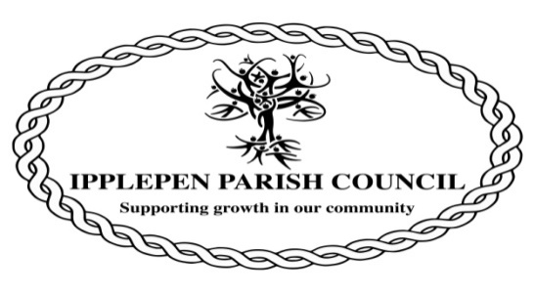

Ipplepen Parish Council - Environmental Policy
Aims
• To promote the importance and value of a quality environment and it’s contribution to quality of life for our community.
• To support our community in it’s enjoyment of our local environment.
• To carry out our work in an efficient way that minimises or eliminates its adverse impact on our environment.
Objectives - The Council will wherever practicable:
• Minimise the creation of waste and, wherever possible, recycle or reuse materials.
• Dispose of all wastes through safe and responsible methods in compliance with relevant environmental legislation.
• Maintain respect for natural resources by ensuring the most efficient use of materials and by using, wherever possible, renewable, recycled and recyclable products.
• Ensure the responsible use of energy throughout the organisation by conserving energy, improving energy efficiency, seeking to utilise safer energy sources and giving preference to renewable over finite energy resources wherever possible.
Activities to achieve the objectives - The Council will:
• Communicate the environmental policy and train its staff to ensure its effective implementation.
• Prepare, implement and monitor action plans to improve performance.
• Review actions and report annually to the Annual Parish Council Meeting.
• The policy will be subject to an Annual review.
With regard to the acquisition of goods and services the Council will:
• Support and encourage contractors and suppliers to minimise their impact on the environment through the communication of its Environmental Policy and aims.
• Use, and specify the use of, used, reclaimed or recycled materials wherever appropriate and possible.
• Actively seek the purchase of materials locally and the appointment of local contractors whenever such materials and skills exist locally.
• The above actions will be pursued in a context where purchasing decisions need to secure good value for money in addition to sound environmental factors.
Each employee and Council member will encourage colleagues to adopt and take responsibility for the implementation of the Environmental Policy.
This policy was adopted by the Council at its Meeting held on 3rd March 2020.
The next date for review is 2nd February 2021.

